**MicroplateGR4, an interactive graphical user interface program to aid in the determination of microbial growth kinetics from microtiter plate optical density data.**

Fred Breidt, USDA/ARS

USDA/ARS Research Microbiologist

Food Science and Market Quality and Handling Research Unit

322 Schaub Hall, Box 7624

NC State University, Raleigh, NC 27695-7624

Email: [fred.breidt@usda.gov](mailto:fred.breidt@usda.gov)

The MicroplateGR4 program was designed to offer flexibility in organizing and calculating growth parameters from 96 well microtiter plate optical density (OD) data. The organization of microtiter plate experiments may vary considerably, and replication is needed for accurate results, so collating and analyzing data can be a daunting task. A graphical interface was developed that allows users to easily select multiple wells or groups of control or inoculated wells for analysis. An underlying database engine facilitates processing, including automated background OD subtraction, natural log transformation of OD data, and curve fitting with commonly used models including the Gompertz or Baranyi models. Results are displayed in exportable graphs and pop-up tables that simplify transfer of data to Microsoft Excel, PowerPoint or other programs for further display or analysis. A sequential processing method for obtaining growth rate, lag time and maximum optical density is used by default to aid in the analysis of difficult to fit curves, and data from multiple processing methods can be compared to assure accuracy of results.

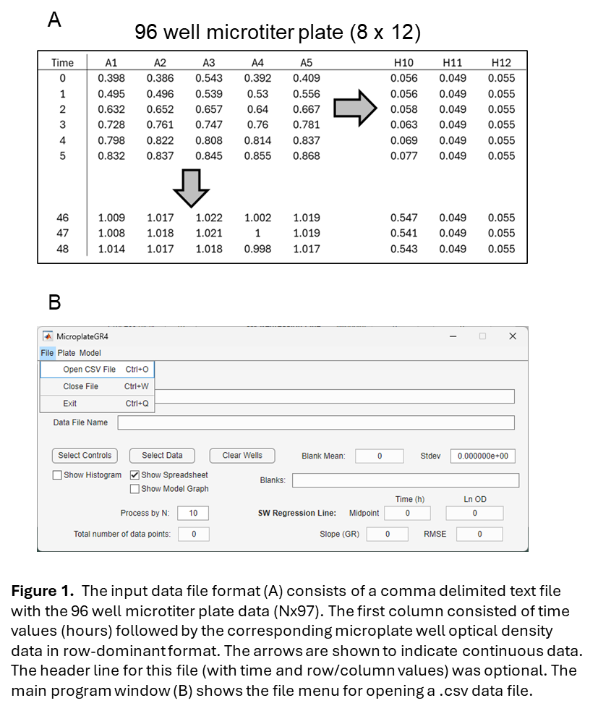Most commercial microtiter plate readers allow the export of data files in Excel, text, or comma delimited spreadsheet format. For use with MicroplateGR4, the data may be converted to a **standardized input comma delimited spreadsheet format (Figure 1A) with a matrix (N rows by 97 columns)**. The first column should contain cumulative time values (hour units) followed by 96 columns of optical density data corresponding to each time value. The number of rows, corresponding to the time interval values will vary depending on how frequently optical density data is sampled. A typical growth curve may contain optical density values recorded every 15 min (0.25 h) for 48 hours. An optional header row may be included in the data file as illustrated (Figure 1). The MicroplateGR4 program is designed to accept data in row-dominant format as shown in Figure 1A, with successive values for each of the 12 columns sequentially ordered by rows (Figure 1A). **The main program window (Figure 1B)** allows the user to select a .csv data file to open for processing using a standard file selection dialog accessed via the File > Open CSV file menu item of MicroplateGR4.

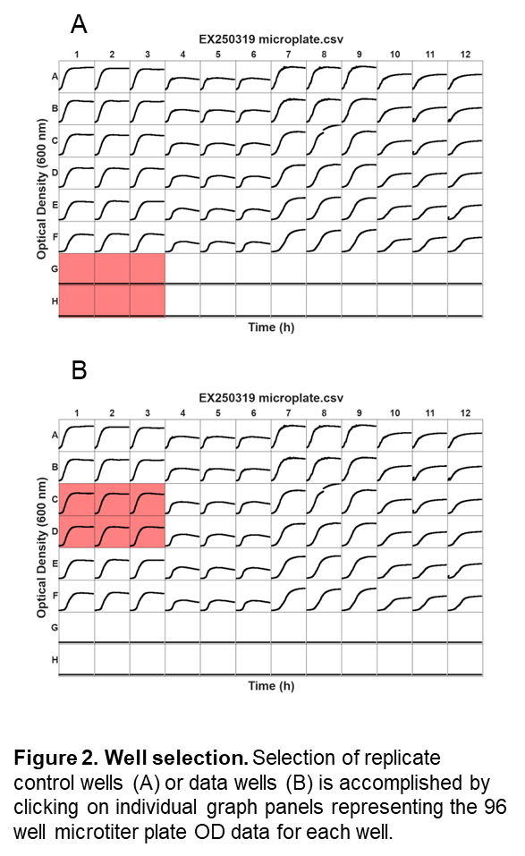Input files may be readily made using Excel if saved as a .csv file. Most microtiter plate readers have a flexible output format that can be compatible with the comma delimited column organization shown in Figure 1. Once a file is selected, a Matlab Figure window opens showing 96 graphs of optical density values from the microplate data file. An example is shown in **Figure 2**.

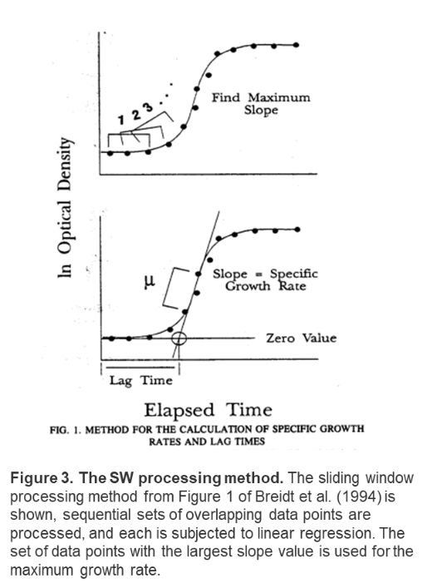This graph is interactive, and the user may select one or more panels in the graph by clicking on individual panels. The corresponding row and column data for the selected well(s) are then used either as blank (control, no cells) or growth curve data. The background color for each selected graph will change to indicate the graph was selected. Clicking again on the same graph will un-select the graph window. Using this method, users should first select control wells representing replicate data as available (Figure 2A) then click on the **Select Controls button.** This action results in setting of the **Blanks** display field and **Blank Mean** and **Stdev** fields on the main program window. An option to display a histogram of the control values is available by selecting the **Show Histogram** checkbox located below the Select Controls button prior to pushing the Select Controls button. This will allow the user to assess the variation in optical density from control wells. Once Select Controls has been pushed, the selected wells in the 96 well figure window are cleared of color shading and the user can then select appropriate growth curves for data corresponding to the blank media controls. Figure 2B shows the selection of 6 replicate growth curves. After selection, the user then presses the **Select Data** button. There are two options for this button **Show Model Graph** and **Show Spreadsheet.** By default, only the Show Spreadsheet option is selected. If both options are selected a graph and table of data are shown. The results show the growth kinetics analysis. For the analysis of growth kinetics, a **sliding window (SW) method** is used as described (Breidt et al., 1994, Atolia et al., 2020). A graphic representation of the algorithm is shown in **Figure 3**. A sliding window of sequential sets of data points are processed to identify the maximum slope for the natural log of the corrected optical density data (equivalent to the maximum growth rate). Because this method does not require curve fitting with a model that has a predefined sigmoidal shape, growth curves with atypical shapes may be successfully processed. Lag time is defined as the elapsed time for the intersection of the slope line and the minimum optical density for the growth curve (as shown in Figure 3). Maximum OD is determined as well. These parameters can 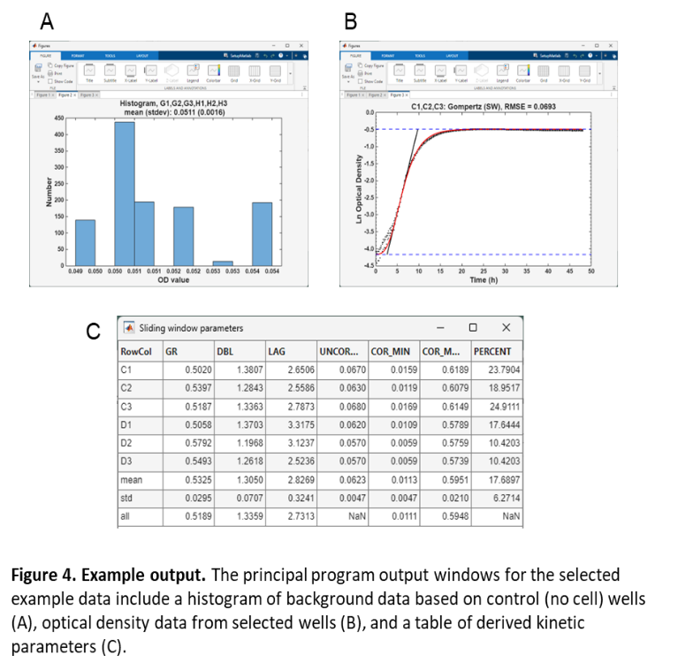subsequently be used to visualize the predicted sigmoidal models for either the Gompertz (Zwietering et al., 1990) or Baranyi (Baranyi and Roberts, 1994) by plotting predicted OD vs. Time. When wells are selected for processing by the Select Data button, the panels remain selected for additional curve fitting or export of OD data. **The Clear Wells** button can be used to remove the selection shading from the panels, or the panels can be deselected by clicking on them individually with the mouse.

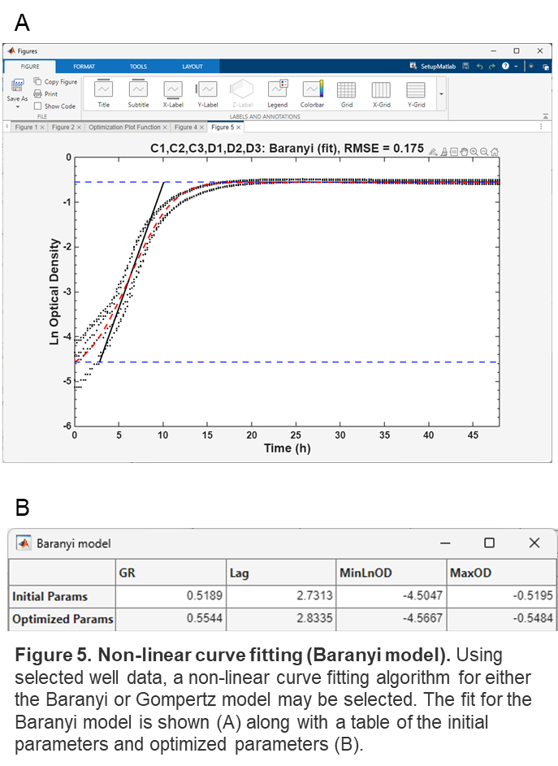Example output data, including the control histogram, a graph of observed and predicted data and a table with the kinetics data for the wells selected are shown in **Figure 4.** The table lists the row and column for each well selected (RowCol), along with data for growth rate (GR), doubling time (DBL), lag time (LAG), uncorrected minimum OD (without background OD subtraction), corrected minimum OD (with background OD subtraction), the corrected maximum OD (with background OD subtraction, and the percent of optical density due to the cells over the background (PERCENT). Because the initial OD from microtiter plate growth curves may influence the derived kinetics, **it is recommended to only use microplate growth curves that have an initial OD with PERCENT values between 5 and 25**. This assures that the initial OD due to the cells was between 5% and 25% of the total optical density due to the medium. The OD due to cells was calculated according to Equation 1:

1. ***% OD due to cells = 100 * (OD with cells – mean background OD)/mean background OD***

In addition to the SW model, MicroplateGR4 includes features for traditional curve fitting with both the Baranyi and Gompertz models, as well as export functions for .csv files that contain raw or processed data from selected curves and models. Output files include exporting the derived kinetics spreadsheet (as shown in Figure 4), raw OD data, or natural log transformed OD data with background subtraction. These features are available under the Plate menu. Finally, the Model menu includes a non-linear curve fitting option that will generate a graph and table of parameters using the data for background wells and the selected panels (**Figure 5**). To switch between the Gompertz or Baranyi model, use the Model > Select Model menu item. This feature gives users an additional option for determining growth kinetics parameters. As with the SW model graph, the root-mean square error for the fit of the model to the data is shown as part of the graph title (RMSE). **The fitting algorithm will be applied to the currently selected panels and model (Gompertz or Baranyi)**. For all of the pop-up tables selecting the data in the table and using the keyboard copy options (Control-C to copy and Control-V to paste) can allow direct pasting of data into Excel other programs. Alternatively, output tables can be generated directly as .csv files using the Plate > Exporte Kinetics data, Export OD data, or Export Ln data menu items. The user will be prompted to select a file name and location for the exported data tables.

**References:**

1. Atolia E, Cesar S, Arjes HA, Rajendram M, Shi H, Knapp BD, Khare S, Aranda-Díaz A, Lenski RE, Huang KC. Environmental and physiological factors affecting high-throughput measurements of bacterial growth. mBio. 2020 Oct 20;11(5):e01378-20. <https://doi.org/10.1128/mBio.01378-20>
2. Breidt, Romick, and Fleming, 1994, J Rapid Methods Autom Microbiol 3(1):59-68. <https://doi.org/10.1111/j.1745-4581.1994.tb00308.x>
3. Zwietering MH, Jongenburger I, Rombouts FM, van't Tiet K. 1990. Modeling the bacterial growth curve. Appl Env Microbiol 56(6):1875-1881. <https://doi.org/10.1128/aem.56.6.1875-1881.1990>
4. Baranyi J, Roberts TA. A dynamic approach to predicting bacterial growth in food. Int J Food Microbiol. 1994 Nov;23(3-4):277-94. <https://doi.org/10.1016/0168-1605(94)90157-0>